**Basketball Quiz**d:\temp\aldendsk\Content.IE5\KTMZMMYG\MC900292486[1].wmf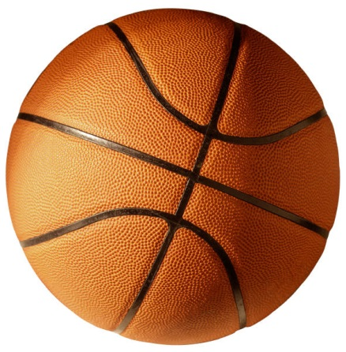  
  
**Name:                                                             Date:**   
  
**1.     What are the dimensions of a standard high school basketball court?**  
  
**a.     94ft x 55ft**  
  
**b.     72ft x 60ft**  
  
**c.      84ft x 50ft**  
  
**d.     100ft x 45ft**  
  
  
  
**2.     In the space below to the best of your abilities, draw 5 referee hands signals.**  
  
  
  
  
  
  
  
  
  
  
  
  
  
**3.     __________ was the founder of basketball.**

**4.     Personal fouls are**  
  
**a.     Moving violations**  
  
**b.     Illegal physical contact**  
  
**c.      The only fouls awarded foul shots**  
  
**d.     Arguing with the referee**  
  
  
  
**5.     Draw a basketball court and label the following areas: Baseline, Sideline, Lane, Midcourt line, Three-point arc, Foul line**